# Assignment 3 help file

This application has only one form but has 3 tabs with different controls

On the main tab (user data)

The user is able to search a user, delete or add a player with the various buttons(the other tabs are disabled until validated). The user affected is the one you typed into the search username box

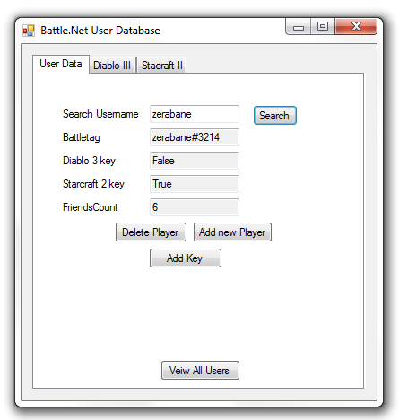

If the username searched matches one in

The database their details are populated

thought the forms and activating the tabs

that where not active. The add key button

is also becomes available here if the player

lacking a key for a game

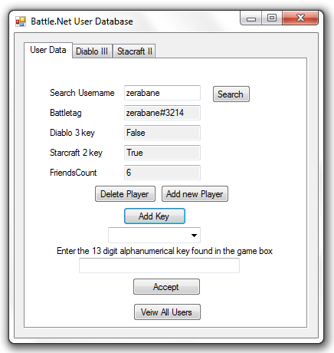

A combo box appears that allows you to choose what game you want to add a key to

Underneath is a textbox this is where you put your games 13-digit serial key found in the box under the disk

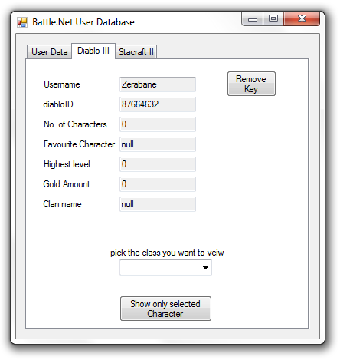

If the key is correct it will enable

Tab of game selected and from

this page you can view all your

game stats, remove your key

or show all users that have a

certain character chosen in the

combobox

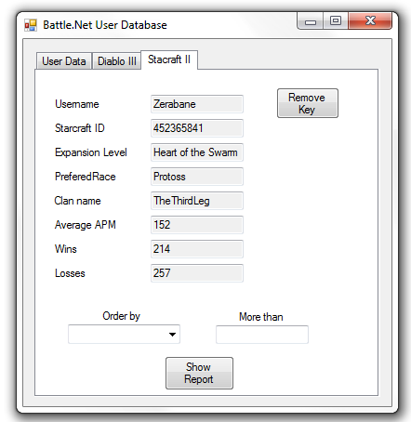

Starcraft tab similar to the diablo tab shows stats for the game and allows you to remove the key. You can also make a report by selecting a field to order the search and then a value the stat has to be better than

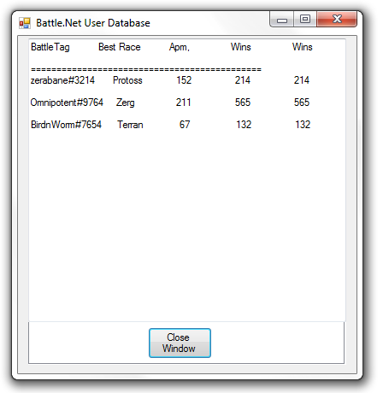

This is an example of the reports

Format, it is the same for all reports

This is for starcraft 2 showing all

players with more than 50 wins